City of York Council

York Sexual Health Needs Assessment
2023

A rapid assessment of the sexual health needs of the York population

Heather Baker Public Health Improvement Officer
January 2023

Contents
Glossary 3
1. Executive Summary and Key Findings 4
2. Scope and Purpose 6
3. The Population of York 9
3.1. Population Size 9
3.2. Sexual Orientation 10
3.3. Gender Identity 11
3.4. Ethnicity 11
3.5. Disability 11
3.6. Population age 11
3.7. Relative Deprivation 12
3.8. Fertility rate 12
3.9. Further reading about the population of York 12
4. Sexual health needs in York 13
4.1. Age and gender 13
4.2. STIs 15
4.3 Chlamydia 16
4.4 Chlamydia Detection 18
4.5 Gonorrhoea 19
4.6 Syphilis 20
4.7 Genital Herpes 21
4.8 Genital Warts 22
4.9 HIV 24
4.10 Late HIV Diagnosis 25
4.11 HIV Testing 25
4.12 Mpox 25
4.13 Sexual Violence 26
5. Reproductive Health 27
5.1 Cervical Screening 27
5.2 HPV Vaccination 28
5.3 Unplanned pregnancy 29
5.4 Abortion 30
5.5 Long-Acting Reversible Contraception 30
5.6 Teenage Conception and Parenthood 31
6. Integrated Sexual Health Service Use 34
7. Recommendations 36

Glossary
AIDS – acquired immune deficiency syndrome
BASHH – British Association for Sexual Health and HIV
BPAS- British Pregnancy Advisory Service
GUM – genitourinary medicine
HIV – human immunodeficiency virus
HNA – health needs assessment
IUD – intra-uterine device
IUS – intra-uterine system
LA – local authority
LARC – long-acting reversible contraception
LSOA – lower layer super output area
MPX – mpox, formerly known as monkeypox
MSOA – middle layer super output area
MSM – men who have sex with men
NEET – not in education, employment or training
NICE – National Institute for Health & Care Excellence
OHID – Office of Health Improvements and Disparities
ONS – Office of National Statistics
PHEIC – Public Health Emergency of International Concern
PHI – Public Health Intelligence
PHOF – Public Health Outcome Framework
PEP – Post-exposure prophylaxis
PEPSE – Post-Exposure Prophylaxis following Sexual Exposure
PrEP – Pre-exposure prophylaxis
SEND – special educational needs and disabilities
STI – sexually transmitted infection
UKHSA- UK Health Security Agency

Executive Summary and Key Findings

This needs assessment looks at the current and emerging sexual health needs of people living in York. This is to help inform the re-commissioning of the City of York sexual health service for 2023-2033. The assessment describes the following:
- The needs of the population
- Key sexual health data
- Service demand, including data analysis from service users and stakeholders
- Key findings

The COVID-19 pandemic meant the implementation of national and regional lockdowns from March 2020 to avert the spread of serious respiratory disease. The measures affected the provision of sexual health services and individuals’ behaviours which is reflected in this assessment’s data. When interpreting data from 2020, the pandemic should be factored in particularly when comparing data from the previous health needs assessment published in 2018.
Sexual health remains an important public health priority. Without timely and accurate diagnosis and treatment, the risk of accidental transmission and medical complications is high. This would present a significant risk to public health, and also increase the demand for costly treatments into the future. Good sexual health is also vital to general wellbeing and has a positive impact in society, regardless of sexual activity.
The costs of delivering sexual health services are outside the scope of this health needs assessment but these will be addressed separately.

The key findings from this needs assessment are:
- Overall, the number of new sexually transmitted infections (STIs) diagnosed among residents of York in 2020 was 960. The rate was 455 per 100,000 residents, lower than the rate of 562 per 100,000 in England, and higher than the average of 412 per 100,000 among its nearest neighbours.

- York ranked 116th highest out of 149 upper tier local authorities (UTLAs) and unitary authorities (UAs) for new STI diagnoses excluding chlamydia among young people aged 15 to 24 years in 2020, with a rate of 378 per 100,000 residents aged 15 to 64, better than the rate of 619 per 100,000 for England.
- The chlamydia detection rate per 100,000 young people aged 15 to 24 years in York was 1,107 in 2020, worse than the rate of 1,408 for England.
- The rank for gonorrhoea diagnoses (a marker of high levels of risky sexual activity) in York was 117th highest (out of 149 UTLAs/UAs) in 2020. The rate per 100,000 was 40.3, better than the rate of 101 in England.
- Among specialist sexual health service (SHS) patients from York who were eligible to be tested for HIV, the percentage tested in 2020 was 59.8%, better than the 46.0% in England.
- The number of new HIV diagnoses among people aged 15 years and above in York was 6 in 2020. The prevalence of diagnosed HIV per 1,000 people aged 15 to 59 years in 2020 was 0.8, better than the rate of 2.3 in England. The rank for HIV prevalence in York was 140th highest (out of 148 UTLAs/UAs).
- In York, in the three year period between 2018 - 20, the percentage of HIV diagnoses made at a late stage of infection (all individuals with CD4 count ≤350 cells/mm³ within 3 months of diagnosis) was 53.3%, similar to 42.4% in England.
- The total rate of long-acting reversible contraception (LARC) (excluding injections) prescribed in primary care, specialist and non-specialist SHS per 1,000 women aged 15 to 44 years living in York was 46.6 in 2020, higher than the rate of 34.6 per 1,000 women in England. The rate prescribed in primary care was 29.7 in York, higher than the rate of 21.1 in England. The rate prescribed in the other settings was 17.0 in York, higher than the rate of 13.4 in England.
- The total abortion rate per 1,000 women aged 15 to 44 years in 2020 was 11.4 in York, lower than the England rate of 18.9 per 1,000. Of those women under 25 years who had an abortion in 2020, the proportion who had had a previous abortion was 19.1%, lower than 29.2% in England.
- In 2019, the conception rate for under-18s in York was 16.4 per 1,000 girls aged 15 to 17 years, similar to the rate of 15.7 in England.
- In 2019/20, the percentage of births to mothers under 18 years was 0.9%, similar to 0.7% in England overall.

Scope and Purpose

The purpose of this Needs Assessment is to consider the current and emerging sexual health needs of York residents.
The primary intended outcome of this Needs Assessment is to inform future sexual health strategies and commissioning decisions over the next three years.
The Needs Assessment includes a description of York’s population and how it is projected to change in the coming years. It also includes a description of the sexual health service use and health outcomes of the population of York. This includes testing and diagnosis of sexual health infections (STIs), contraception, conception, and pregnancy termination among teenagers.
The following information sources were used as part of this Needs Assessment:
- Routinely collected data indicators. For example, Office of Health Disparities and Improvements (OHID) Fingertips, Business Intelligence (BI) data, and any Census 2021 data

- Specialist reports: York Local Authority HIV, (SPLASH) (formerly the sexual and reproductive health epidemiology report (LASAR)), OHID 2021

- Extracts from recent York topic needs assessments produced as part of the Joint Strategic Needs Assessment

- Data provision from service providers about people who have used the integrated wellbeing service in the last year

- Information collected from residents about their views of sexual health services in York

The views of organisations and professionals have not been formally collected as part of this needs assessment. There will be an extended engagement and consultation period as part of planned commissioning work in 2023, and this will include the opportunity to discuss sexual health need in York.

Commissioning Responsibilities and Quality Standards
Sexual health services are commissioned locally to meet the needs of the population. Local authorities are responsible for commissioning the following services:
- comprehensive sexual health services including most contraceptive services and all prescribing costs, but excluding GP additionally-provided contraception
- sexually transmitted infections (STI) testing and treatment, chlamydia screening and HIV testing
- specialist services, including young people’s sexual health, teenage pregnancy services, outreach, HIV prevention, sexual health promotion, services in schools, college and pharmacies

In York, sexual health services are delivered through an integrated model. This allows for genitourinary medicine (GUM) and contraception and sexual health (CASH) services to be delivered through a main hub and spoke sites.
Hub site:
Monkgate Health Centre, YO31 7WA

Spoke sites:
Unity Health, Wenlock Terrace (BPAS), YO10 4DU
Acomb Front Street, YO24 3BZ *temporarily closed* plans to reopen
University of York, YO10 5DD *temporarily closed* plans to reopen
Askham Bryan College, YO3 3FR *temporarily closed* plans to reopen

Comment: Prior to the COVID-19 pandemic, three spoke sites provided satellite services across York, particularly where higher and further education facilities were proximal. As a result of the pandemic, these spoke sites were temporarily closed. There is discussion to reopen these in the near future.

As of July 2022, Clinical Commissioning Groups become Integrated Care Systems (ICS). The Humber and North Yorkshire Heath and Care Partnership now has a single NHS Integrated Care Board (ICB) which oversees the day-to-day running of services provided by The York & Scarborough NHS Trust. The ICB is responsible for commissioning the following services:
- most pregnancy termination services
- sterilisation
- vasectomy
- non-sexual health elements of psychosexual health services
- gynaecology, including any use of contraception for non-contraceptive purposes

NHS England is responsible for commissioning the following services:
- contraception provided as an additional service under the GP contract
- HIV treatment and care (including drug costs for PEPSE)
- promotion of opportunistic testing and treatment for STIs and patient-requested testing by GPs
- sexual health elements of prison health services
- sexual assault referral centres
- cervical screening
- specialist foetal medicine services

Other sexual health services commissioned in York:

The commissioning of LARC in Primary Care in York is a shared responsibility between the council and the NHS Humber and North Yorkshire Integrated Care Board (ICB). The service is commissioned by the council on behalf of the ICB via a Section 75 agreement dated 30 October 2019, which commits both organisations to commissioning LARC through shared responsibility and budget allocation. This Section 75 agreement is in place until 31st March 2026.

British Association for Sexual Health and HIV (BASHH) Guidelines
The British Association for Sexual Health and HIV produces a number of guidelines on the practical delivery of quality sexual health services. In total there are currently 25 recommendations which cover a wide range of sexual, reproductive, and gynaecological topics. Particularly relevant are the guidance documents on sexual history taking, STI testing and HIV1
There are five main public health outcome measures for these services. These are included in the Public Health Outcomes Framework profile:
- under 18 conceptions
- chlamydia detection rate
- new STIs diagnosis (excluding chlamydia in the under 25s)
- prescribing of long-acting reversible contraception (LARC) excluding injections (females aged 15 to 44)
- people presenting with HIV at a late stage of infection.

The Population of York

3.1. Population Size
York has 202,800 citizens as recorded by the 2021 Census. Since 2011, the population has increased by 2.4%.
There are marginally more people who identify as females (51.9%) than males. York benefits from a diverse cross-section of age groups with similar values observed from 4 years and under to 90 years and over. The most common age group for residents is 20-24 years (10.1%) likely down to York’s two main universities and the further education establishments of York College and Askham Bryan College.

Figure 1: Population pyramid of York v. England
Figure one above indicates that a significantly larger proportion of people aged late teens and early 20s reside in York than the England average:
- 7.5% of York’s population are 15 to 19 years old
- 10.1% of York’s population are 20-24 years old
- 6.41% of York’s population are 25-29 years old
Fishergate, Guildhall, and Hull Road wards are resident to the majority of people aged 16-24 years, likely due to proximity and access to educational establishments and good transport links. Further details can be found in the ward profiles.

3.2. Sexual Orientation
In 2020, an ONS statistical bulletin on sexual orientation was published that estimated that 93.6% of the UK population aged 16 years and over identified as heterosexual or straight. An estimated 3.1% identified as lesbian, gay or bisexual (LGB), an increase from 2.7% in 2019. The proportion of men identifying as LGB increased from 1.9% in 2014 to 3.4% in 2020. Over the same period, women identifying as LGB increased from 1.4% to 2.8%. This would translate to approximately 10,794 LGB people living in York.
Data from the Census 2021 was released in early January 2023. 89.37% of the national population stated they were straight or homosexual. Of the York population, 86.5% (n = 148,921) of people aged 16 years and over stated they identified as either straight or heterosexual. 2.04% (n = 3,507) identified as gay or lesbian; 2.85% (n = 4,904) as bisexual, and a remaining 0.66% (n = 1,143) as pansexual, asexual, queer, and other respectively. 7.91% (n = 13,610) did not disclose their sexuality.

3.3. Gender Identity
In the Census 2021, 93.41% (n = 161,735) of York residents aged 16 years and over stated their gender identity was the same as their sex registered at birth. 0.18% (n = 318) stated they were non-binary; 0.20% (n = 341) identified as either a trans man or trans woman, and 0.09% (n = 161) described themselves as another gender identity. 0.14% (n = 242) stated their gender identity was different from their sex registered at birth but gave no specific identity. 5.98% (n = 10,286) did not give an answer.

3.4. Ethnicity
87.3% (n = 176,963) of York residents describe themselves as “White: English, Welsh, Scottish, Northern Irish or British in the 2021 Census. This is a 6.7% decrease since data from the previous sexual health needs assessment. People who identify as Other White make up the largest ethnic cohort at n = 9297 (4.6%). The largest single ethnic minority cohort is Chinese with 2,889 people (1.4%) identifying as this cohort.

3.5. Disability
Across all of York, 15.3% of residents are recorded as having ‘limiting long term illness or disability’ which impacts on their daily lives.

3.6. Population age
Age is particularly important in this needs assessment because young people, particularly those aged 16-24 years old have a higher need for sexual health services.

3.7. Relative Deprivation
A 2021 report published by the former Public Health England (PHE), now Office of Health Improvements and Disparities (OHID), explored the variation in outcomes of sexual and reproductive health in England. It was recognised that STI incidence rates were consistently higher in more deprived populations which was particularly true of young people.

3.8. Fertility rate
York’s general fertility rate, five-year pooled data from 2016-2020) was 39.7 live births per 1,000 women aged 15 to 44 (England 59.2/1,000). This amounts to approximately 1800 live births in York on any given year. This is important to consider when planning contraception and sexual health services.

3.9. Further reading about the population of York
- York Joint Strategic Needs Assessment https://www.healthyork.org/
- York Open Data https://www.yorkopendata.org

Pharmaceutical Needs Assessment (2022)

This needs assessment considered the population need for community pharmacy services 2022–2025. 21% of residents reported in the assessment’s residents survey that they would find it useful if their local pharmacy offered NHS screening services, including HIV. None of the responding pharmacies stated they were delivering a chlamydia testing service. Two pharmacies stated that a sexual health/chlamydia testing and treatment locally commissioned service was required in York.
Pharmacies were also recommended to support the following services to decrease the number of teenage pregnancies in York:

- C-card scheme (access to free condoms and lube)
- Emergency hormonal contraception
- Pregnancy testing
- Referral on for further contraception services
Free emergency hormonal contraception is available through general practice or specialist sexual health services in York without appointment.

Homelessness health needs assessment (2018)

The 2018 needs assessment considered the health and wellbeing of people in York who were sleeping rough, sofa surfing, in temporary or insecure accommodation. It found that people generally had good awareness of sexual health services in York, the majority knew where to access free condoms and sexual health advice. Additionally, the majority were registered with a GP.

Student Health Needs Assessment (2017)
This needs assessment considered the health and wellbeing of students studying at the universities and colleges in York. Generally, students had a good level of awareness of local sexual health services, including where to go for advice and contraception. However, there were some concerns among staff and students about the emotional aspects of sexual relationships.

4. Sexual health needs in York

4.1. Age and gender

Figure 2: Population Pyramid stratifying STI diagnoses by age and gender 2018-2022
Age and gender are important considerations in sexual health. Nationally and in York, sexually active young people are more likely to be diagnosed with an STI than other age groups:
- 20-24 years account for 10% of the York population but 42% of STI diagnoses made

- 15-19 years account for 7.5% of the York population but 22% of STI diagnoses made

- It is very uncommon for young people under 15 years in York to have STIs. In the preceding five years, only two diagnoses were made

Figure 2 indicates that women and girls accounted for 53% of new STI diagnoses made in York between 2018 and 2022. However, the seven diagnoses made in people aged 65 years and over were in men. The age cohort with the highest number of new STI diagnoses was 20-24 years, accounting for 42% of all diagnoses.

4.2. STIs
STIs comprise of 30 different bacterial, viral and parasitic infections transmitted through sexual contact. Eight pathogens are associated with the largest incidence of STIs, of which four are curable: chlamydia, gonorrhoea, syphilis and trichomoniasis. The remaining four are incurable viral infections: hepatitis B, herpes simplex virus (HSV), HIV and human papillomavirus (HPV). The emergence in recent years of new infections that may be acquired through sexual contact have also been a cause for concern, including mpox, ebola and zika.
STIs are often asymptomatic and frequent STI screening of groups with greater sexual health needs is important. Early detection and treatment can reduce long-term consequences, such as infertility and ectopic pregnancy. In some cases, vaccination can be a useful intervention for some infections like genital warts, HPV, hepatitis A and hepatitis B. However, the control of other STIs is reliant on correct and consistent condom use, behavioural changes to reduce multiple and overlapping partners and prompt notification and testing of partners’ sexual health in the event of a positive result.
In response to the COVID-19 pandemic, and ensuing restrictions, sexual health services (SHS) in England had substantially reduced capacity to deliver face-to-face consultations but underwent rapid reconfiguration to increase access to STI testing via telephone or internet consultations. STI testing and diagnoses decreased across all infections between 2019 and 2020. Over this period, larger decreases in diagnoses were observed for STIs that are usually diagnosed clinically at a face-to-face consultation, such as genital warts or genital herpes, when compared to those that could be diagnosed using remote self-sampling kits such as chlamydia and gonorrhoea.³ In 2020, STIs continued to disproportionately impact gay, bisexual and other men who have sex with men (MSM), young people aged 15 to 24 years, and people of Black Caribbean ethnicity.
This report has been compiled using data from SHS and ‘community-based’ settings routine returns to the GUMCAD STI and CTAD Chlamydia surveillance systems.
‘Sexual health services’ refer to services offering specialist (level 3) STI-related care such as genitourinary medicine (GUM) and integrated GUM and sexual and reproductive health (SRH) services. They also include other services offering non-specialist (level 1 or level 2) STI-related care and community-based settings such as young people’s services, internet services, termination of pregnancy services, pharmacies, outreach, and general practice. Further details on the levels of sexual healthcare provision are provided in the BASHH Standards for the Management of STIs.
Table 1: Rates per 100,000 population of new STIs in York and England: 2019-2020
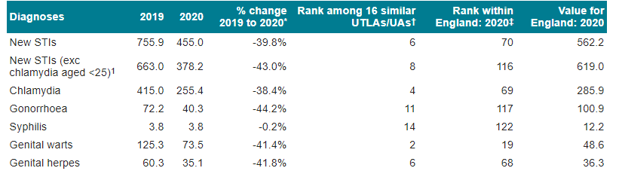

4.3 Chlamydia
Chlamydia is caused by the bacterium chlamydia trachomatis and is the most common bacterial sexually transmitted infection in England. Most people with chlamydia do not experience any symptoms and so may not know they have it. If untreated, chlamydia can lead to complications including pelvic inflammatory disease, ectopic pregnancy and infertility. There are specific indicators for 15-24 year-olds, because chlamydia disproportionally affects young people.
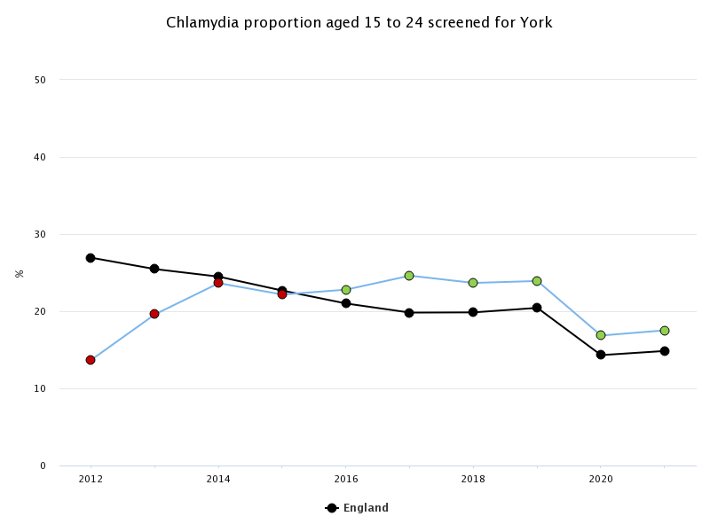
Figure 3: Chlamydia screening activity in York and England 2012-2021
Figure 3 shows that chlamydia screening in York was significantly worse than the national average for the first three years. However, from 2016 onwards, screening has been above the national average and has followed a similar trend- rates in 2020 fell due to the COVID-19 pandemic but are beginning to pick up. In 2021, 6,615 (17.5%) young people aged 15-24 were screened for chlamydia. This is significantly better than the national average of 14.8%.

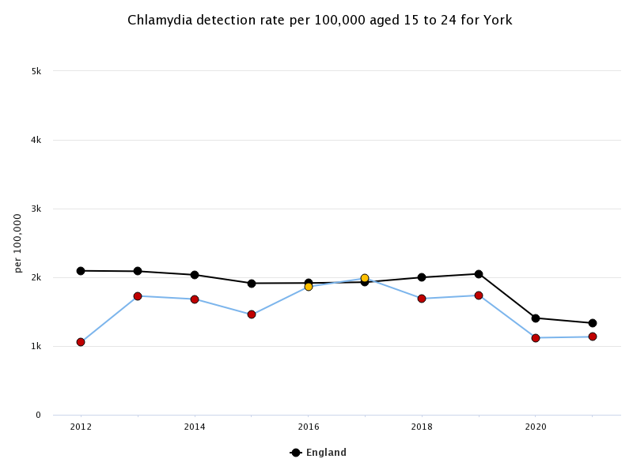
Figure 4: Chlamydia detection rate in York and England, 2012-2021
The national target for chlamydia detection rate in 2021 for people aged 15-24 years was 1,762 per 100,000. York’s rate in the same year is 1,134 per 100,000 which is significantly lower, a trend seen in all but two years in the time measured. The rate amounts to 428 diagnoses of chlamydia.

4.4 Chlamydia Detection
In June 2021, the National Chlamydia Screening Programme (NCSP) changed to focus on reducing the harms from untreated chlamydia infection. These harms occur predominantly in young women and other people with a womb or ovaries - this includes transgender men, non-binary people assigned female at birth, and intersex people with a womb or ovaries. Therefore, opportunistic screening should focus on these groups, combined with reducing time to test results and treatment, strengthening partner notification and re-testing after treatment.
In practice this means that chlamydia screening in community settings (e.g. GP and Community Pharmacy) will only be proactively offered to young women and other people with a womb or ovaries. Services provided by sexual health services remain unchanged and everyone can still get tested if needed.
Given the change in programme aim, the Public Health Outcome Framework (PHOF) Detection Rate Indicator (DRI) benchmarking thresholds have been revised and will be measured against females only. A new female-only PHOF benchmark DRI will be included in the PHOF from January 2022 (to be reported in 2023).

4.5 Gonorrhoea
Neisseria gonorrhoea is a common STI which can lead to serious complications including pelvic inflammatory disease, ectopic pregnancy and infertility. Initial symptoms can include discoloured discharge from the vagina or penis, dysuria and for women bleeding between periods.
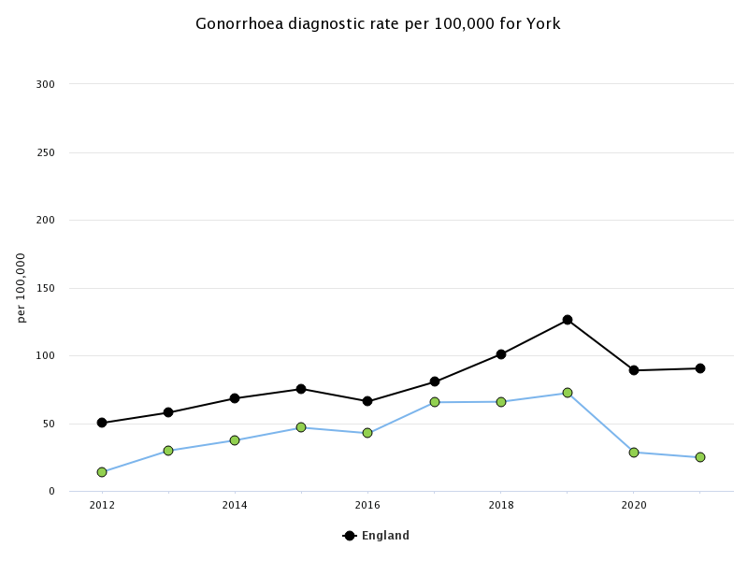
Figure 5: Gonorrhoea diagnostic rates in York and England 2012-2021

Figure 5 shows that diagnosis rates of gonorrhoea were rising gradually until 2019 before a sharp fall in 2020. Rates continued to decrease in 2021, most likely due to national lockdown measures affecting sexual health services. In 2021, 52 cases of gonorrhoea were diagnosed (25 per 100,000 people), 100 fewer than in 2019 (n = 152, or 72 per 100,000). The diagnosis rate nationally was 90 per 100,000 in 2021 (126 per 100,000 in 2019).
Gonorrhoea is usually treated effectively with antibiotics. These can be administered empirically where there is a high likelihood of a positive diagnosis, such as the presentation with the above symptoms.

4.6 Syphilis
Syphilis is a bacterial infection. Undiagnosed, people with syphilis can experience ‘late stage’ complications, sometimes several decades after the original infection. This may include poor coordination, paralysis, numbness, blindness, dementia, fatal organ damage.
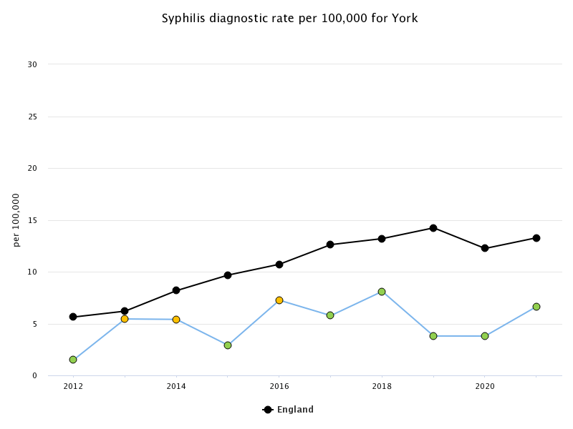
Figure 6: Syphilis diagnostic rate 2012-2021
There were 14 diagnoses of syphilis in 2021, or a rate of 6.6 per 100,000 people. There is no obvious trend in York with cases either doubling in one year, or falling sharply since 2012. This is in contrast with the national trend where cases have been gradually increasing. In 2019, PHE published an action plan addressing the increase in syphilis in England. The report indicates that public health measures need to be strengthened in order to reduce transmission of syphilis. Syphilis rates are higher among men who have sex with men (MSM) but risk factors also include multiple sexual partners, substance use such as during “chemsex” and transactional sex. Four prevention pillars have been optimised for control and prevention:
1. Increase testing frequency of high-risk MSM and re-testing of syphilis cases after treatment
2. Deliver partner notification to BASHH standards
3. Maintain high antenatal screening coverage and vigilance for syphilis throughout antenatal care
4. Sustain targeted health promotion

4.7 Genital Herpes
Genital herpes simplex virus is a common sexually transmitted infection. It causes groups of small painful blisters which occur in periodic recurrent episodes. This means that people with genital herpes live with the condition longer after diagnosis than they would with many other forms of STI.
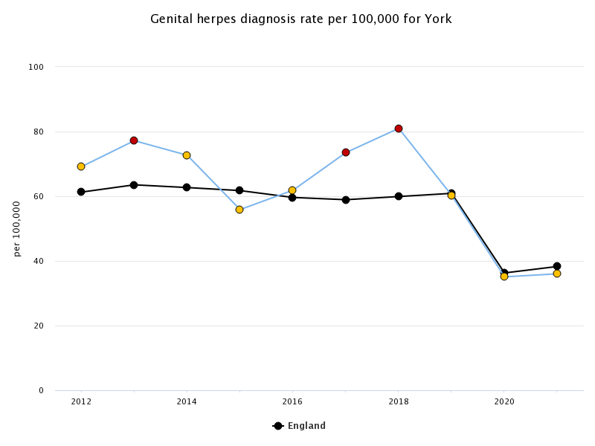
Figure 7: Genital herpes diagnosis rate per 100,000 2012-2021
Figure 7 shows a mixed picture in York. In the years immediately prior to the Covid-19 pandemic, the diagnosis rates were significantly worse than the national average (n = 170, 81 per 100,000 people in 2018). In 2019, rates fell to 60.3 per 100,000 in line with national averages.

4.8 Genital Warts
Genital warts (condylomata acuminata) are soft fleshy growths that appear on the genitals and can cause pain, discomfort and itching. They are a common STI caused by the HPV virus.

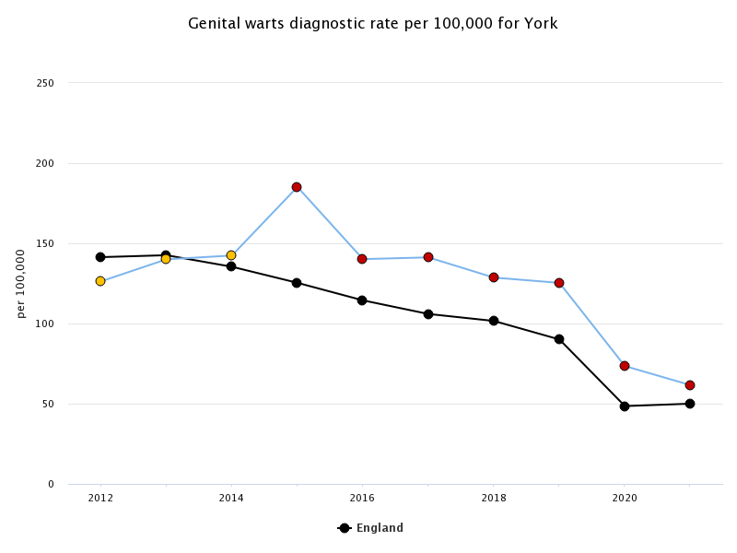
Figure 8: genital warts diagnostic rate per 100,000 2012-2021
Figure 8 indicates that whilst the number of diagnoses is reducing in line with national rates, York still has a significantly higher rate of new cases. In 2015, cases rose by 30% to 185.1 per 100,000 (n = 381) people before falling in 2016 to the original 2014 rates (142.4 per 100,000 people; n = 290). Since then, cases have gradually reduced each year with 2021 rates at their lowest at 61.6 per 100,000 people (n = 130).

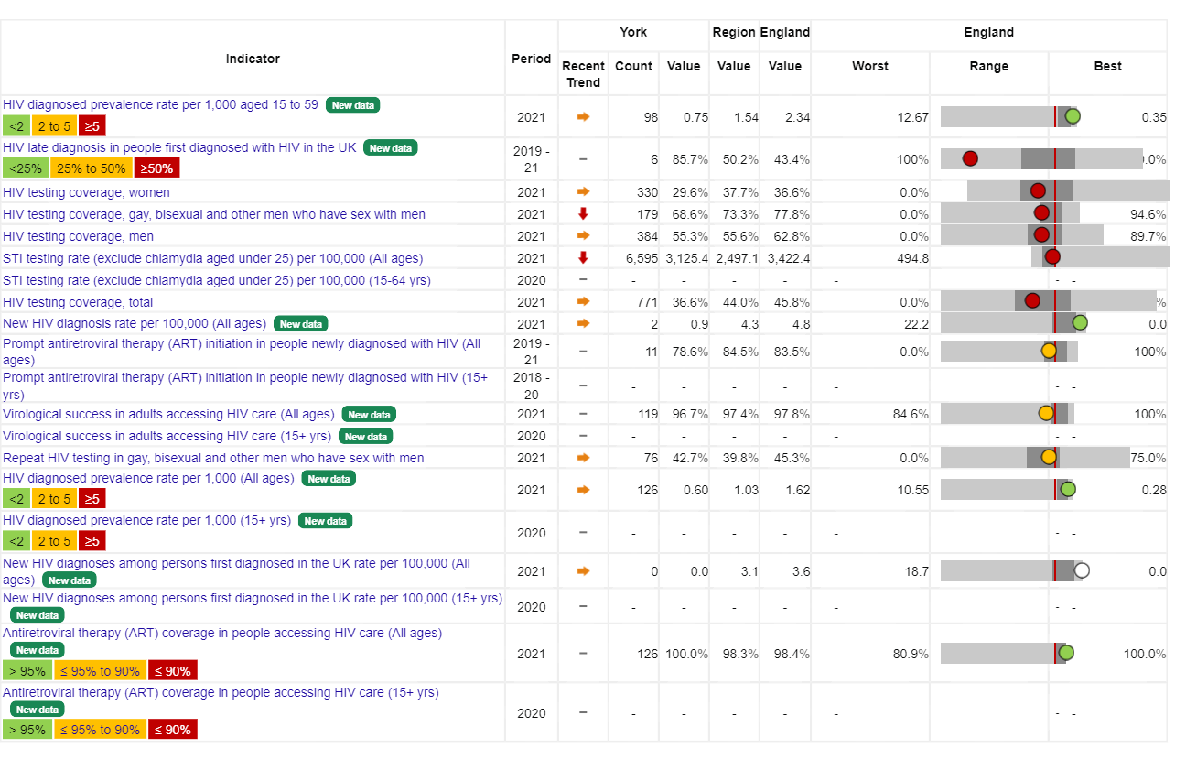
4.9 HIV
Human immunodeficiency virus (HIV) is a chronic infection that attacks the body’s CD4+ T helper cells, white blood cells that play an essential part to the human immune system. Whilst incurable, HIV can be managed by timely diagnosis and consistent treatment however patients can still be at risk of opportunistic infections and some cancers. With advances in treatment, people living with HIV can expect to have a similar life expectancy to HIV-negative people. Left untreated however, HIV will progress to acquired immune deficiency syndrome (AIDS). Damage to the immune system at this stage can cause serious AIDS-defining illnesses such as tuberculosis (TB), pneumonia and cancer.
In 2020, the number of York residents aged 15 years and older who were newly diagnosed with HIV in the UK was 4. The rate of new diagnoses per 100,000 residents was 2.2, similar to the rate of 4.3 per 100,000 in England. This represented a 20% decrease since 2019 and a 68% decrease in the 5 years since 2015. The rank of York for the rate of new HIV diagnoses was 110th highest (out of 148 UTLAs/UAs).

4.10 Late HIV Diagnosis
Late diagnosis is an extremely important predictor of HIV-related morbidity and mortality. Late diagnosis is defined as having a CD4 count of <350 dells/mm³ within 91 days of first HIV diagnosis in the UK. This is a PHOF indicator whereby monitoring is essential to evaluate HIV testing efforts.
For York residents, the percentage of HIV diagnoses made at a late stage of infection for different risk groups in the three-year period between 2018 - 20 was as follows: MSM - 40.0%, similar to 33.7% in England; heterosexual men - 50.0%, similar to 55.6% in England; heterosexual women - 100%, similar to 46.8% in England.

4.11 HIV Testing
In 2020, among York residents, the percentage of eligible SHS attendees who received an HIV test was 59.8%, better than 46.0% for England. This represented a 11% decrease since 2019, and a 21% increase since 2015. For 2020, the percentage of MSM in York who had tested more than once in the previous year was 43.3%, worse than 52.0% in England.

4.12 Mpox
Mpox, formally known as monkeypox is a zoonotic infection caused by the monkeypox virus. Since 6 May 2022, Mpox in the UK has been declared as a Public Health Emergency of International Concern (PHEIC). Cases have occurred mainly in West and Central Africa however there have been reports of incidence in the UK prior to 2022. These cases had either been imported from countries where monkeypox is endemic or were contacts of people with links to imported cases. Whilst it is not a sexually transmitted infection, the main route of transmission in UK cases has been through sexual contact, observed mostly in gay, bisexual, and men who have sex with men with no documented history of travel to endemic countries.
The current epidemiological situation as of 12 December 2022 shows there have been 3,582 confirmed and 148 highly probable cases detected in the UK. 3,552 of these were in England. To date, 84 (2.4%) have occurred in Yorkshire and Humber and no new cases have been reported in Yorkshire and Humber since 10 October.

4.13 Sexual Violence

Sexual violence is a non-legal term that encompasses acts which range from verbal harassment and coercion to forced penetration. Sexual violence includes, but is not limited to:
- Unwanted sexual advances or sexual harassment (eg. in the workplace)
- Rape by strangers or acquaintances
- Rape within marriage or a relationship
- Systematic rape or sexual slavery, trafficking
- Rape and sexual abuse of children
- “customary” forms of sexual violence, including forced marriage, wife inheritance
- Female genital mutilation
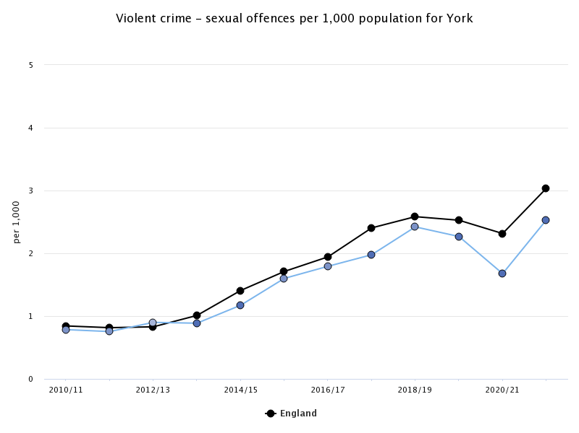
Figure 9: Trend graph showing sexual offences per 1000 population in York
Figure 9 shows that cases of sexual assault have been gradually rising in both York and nationally with York rates averaging at approximately 1.6 cases per 1000 population since 2010. Since 201 however, rates per 1000 population have averaged 2.2. A slight drop rates from 2.3 to 1.7/1000 is seen in 2020/21 data most likely due to lockdown measures during the Covid-19 pandemic. In 2021/22, rates increased to 2.5/1000 most likely due to a relaxation of lockdown rules.

Rape
The Rape Monitoring Group (RMG) is a multi-agency group in England and Wales that is coordinated by His Majesty’s Inspectorate of Constabulary and Fire & Rescue Services (HMICFRS). Each year, the RMG has published data that covers the three stages of the criminal justice process for rape: the report and investigation of an incident; prosecution; trial and eventual outcome. The City of York falls under the North Yorkshire Police Constabulary to which the data below pertains to. As North Yorkshire Police covers an area of approximately 3,208 square miles, this data represents not just the City of York.

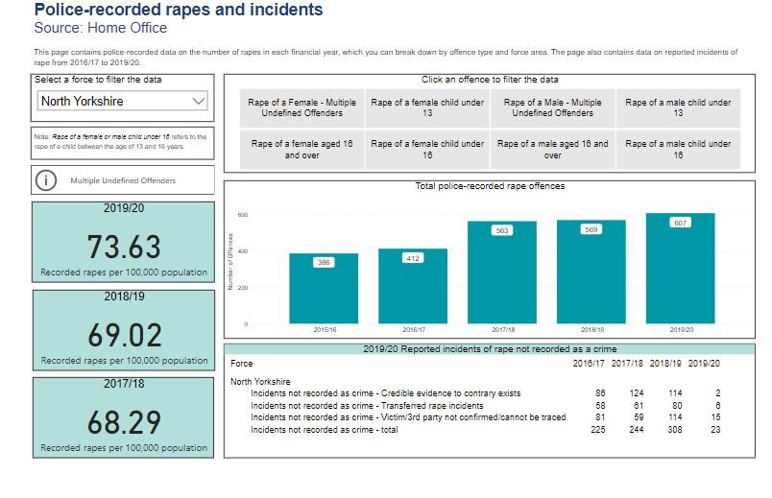
Figure 10: Police-recorded rapes and incidents in North Yorkshire 2015-2020
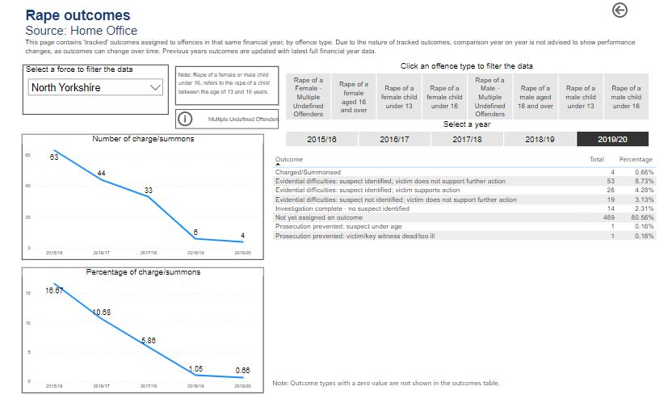
Figure 11: Rape outcomes in North Yorkshire

5. Reproductive Health
The pandemic had a significant impact on access to long acting reversable contraception (LARC) fitting and removals. This was mainly due to the change in requirements for face-to-face appointments, however fears around contracting COVID-19 may have also led to reluctance in seeking LARC. In March 2020, the Faculty of Sexual and Reproductive Health (FSRH) advised bridging methods to individuals unable to access LARC. These were to be readily available and included hormonal contraception such as the progestogen-only pill.

5.1 Cervical Screening

Cervical screening, also known as a pap smear or smear test, checks the health of a cervix for any changes to the squamous cells that line the ectocervix, or outer surface of the cervix. Screening is offered to all women and people with a cervix between the ages of 25 and 64 years. Abnormal cervical intraepithelial neoplasia (CIN) can be detected in some women following the procedure which are graded 1-3 depending on severity. This is not a cancer diagnosis however a referral to colposcopy for closer investigation is required in order to prevent neoplasia from progressing to cancer. Cervical cancer is almost always due to a positive human papillomavirus (HPV) infection, however risk factors for developing the disease can also include:
- Becoming sexually active before 18 years
- Having multiple sexual partners
- Sexual intercourse with someone who either has HPV infection or has had multiple sexual partners
- Smoking- tobacco by-products can be found in cervical mucosa which may damage cell DNA
- Immunosuppression, especially due to HIV
- Chlamydia infection
- Long-term use of oral contraceptives

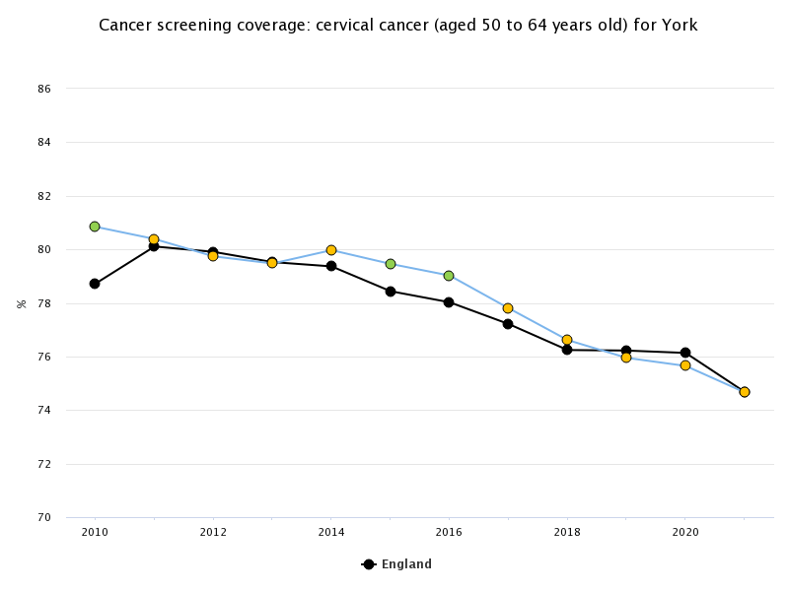
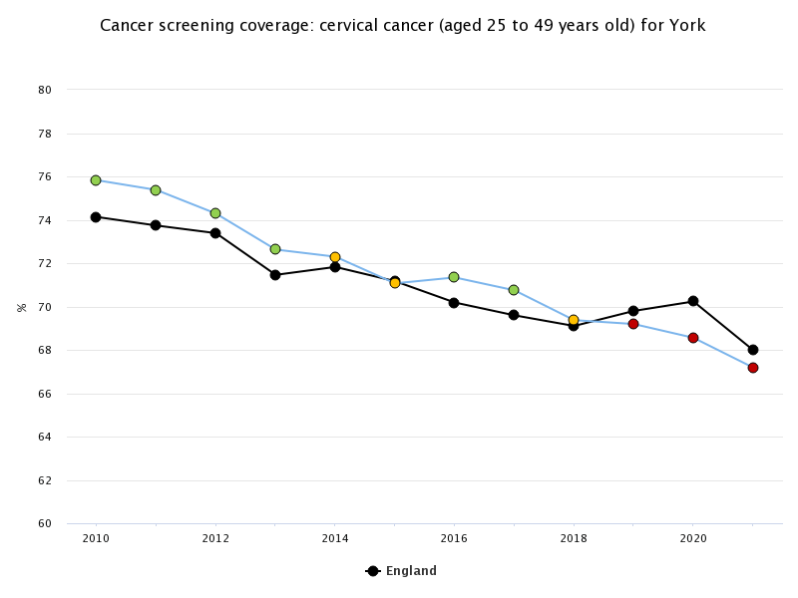
Figure 12: Figure 9: Cancer screening coverage: cervical cancer (age cohorts 25-49 years and 50-64 years)

Figure 12 shows that the numbers of women attending cervical screening has gradually declined, both in York and nationally. This is despite campaigns to encourage women and people with a cervix to attend cervical screenings.

5.2 HPV Vaccination

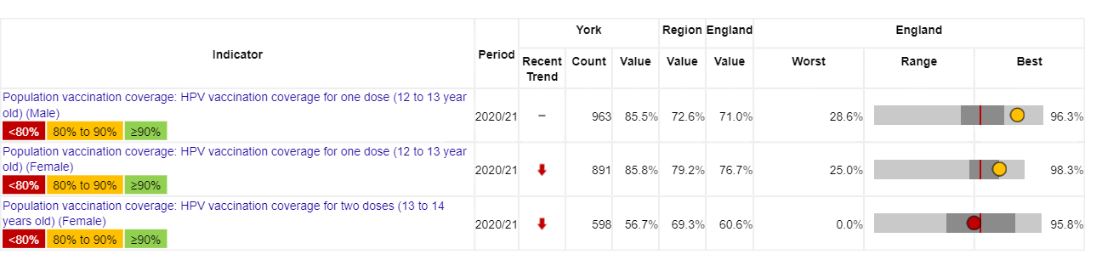
In recent years, vaccination against human papillomavirus (HPV) has contributed to reduced cancer mortality and morbidity rates to an extent that WHO believes it can be eliminated as a public health problem by 2030. HPV can also cause other cancers, including those of the vagina, penis and anus. HPV can also cause genital warts.
Figure 13: HPV Vaccinator coverage in York compared with England
Figure 13 shows the vaccination coverage of the HPV virus in York stratified by gender, and numbers of doses. The total proportion of teenagers aged 12-13 years who have received one dose is 85.7% (n = 1854). For males, this is statistically similar to the national average. For females receiving one or two doses, the trend shows decreasing numbers are receiving the vaccine at a rate that is statistically worse than England. The reasons for this are multi-factorial. HPV is seen as a sexually transmitted infection with some parents believing their children would be encouraged to have sex. Vaccine efficacy has also been highlighted as a concern with links to chronic fatigue syndrome and complex regional pain syndrome. Recommendations from clinicians and social media personalities such as TikTok influencers have been shown to have a huge positive impact on uptake.

5.3 Unplanned pregnancy
Unplanned pregnancy can end in maternity, miscarriage or termination. Whilst many will continue to maternity, unplanned pregnancy can cause financial, housing and relationship pressures with negative health impacts and adverse impacts on existing children. As such, restricting access to contraception by age can be counterproductive.
The Third National Survey of Sexual Attitudes and Lifestyles (NATSAL-3), which was carried out in Britain in 2010-12, found that 16.2% of all pregnancies in the year before the study interview were unplanned. This survey found that:
- Pregnancies among 16- to 19-year-old individuals accounted for 7.5% of the total number of pregnancies, but 21.2% of the total number that were unplanned.
- The highest numbers of unplanned pregnancies occur in the 20 to 34 year age group.
- 42% of the unplanned pregnancies ended in an abortion, 32% ended in a miscarriage and 25% went on to a full term pregnancy

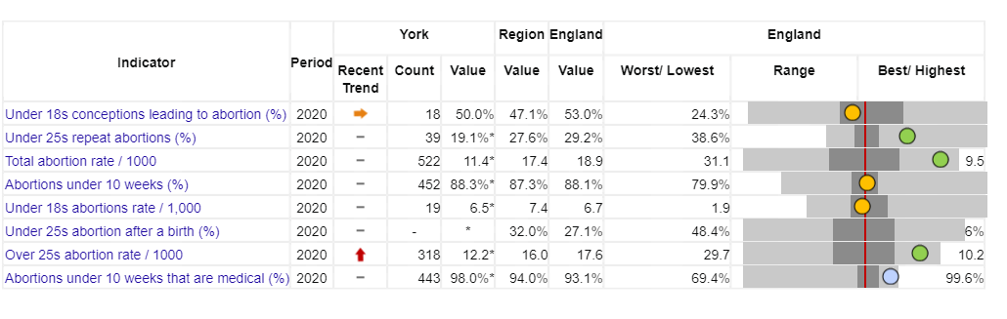
5.4 Abortion
Figure 14: Chart showing key abortion indicators in York compared to England
The total number of abortions in 2020 was 522. The total abortion rate per 1,000 female population aged 15 to 44 years was 11.4, lower than the rate in England of 18.9 per 1,000. The rank (out of 149 UTLAs/UAs) within England for the total abortion rate was 148th highest.

5.5 Long-Acting Reversible Contraception
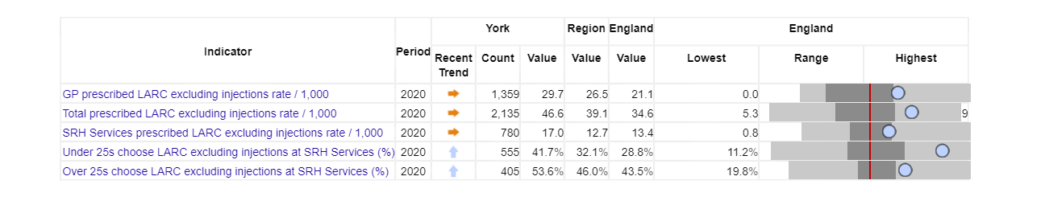
There was a significant drop in the prescribing of IUD, IUS and implants from April 2020 due to the pandemic. The total rate of long-acting reversible contraception (LARC) (excluding injections) prescribed in York primary care, specialist and non-specialist SHS was 46.6 per 1,000 women aged 15 to 44 years in 2020, higher than the rate of 34.6 per 1,000 women in England.

LARC provision is likely to reflect local geography and service models. For example, there may be more provision in primary care in more rural and semi-rural areas. In York, the rate prescribed in primary care was 29.7 in 2020, higher than the rate of 21.1 in England. The rate prescribed in the other settings was 17.0 in 2020, higher than the rate of 13.4 in England.

5.6 Teenage Conception and Parenthood

Teenage pregnancy is a complex issue with multiple factors that affect rates and experiences of mothers and babies. Access to sexual education, contraception and behavioural advice are some of these contributary factors. Deprivation also plays a key role with higher rates observed in more deprived areas yet fewer conceptions leading to termination.
A small cohort of teenage women find pregnancy a positive experience. For others however the experience is more challenging. Young mothers are more likely to have poorer education outcomes including fewer qualifications and a greater likelihood of long-term unemployment. They are also more likely to experience poverty and post-natal depression. Adolescent mothers are also at a higher risk of developing complications such as stillbirth, eclampsia and systemic infections than in older mothers. Babies of adolescent mothers are also at increased risk of low birth weight, preterm birth and severe neonatal illness. Teenagers are also most likely to present late for antenatal care and for abortion services. Efforts to minimise late pregnancy diagnosis and therefore delayed referrals to maternity or abortion services should be prioritised.
The introduction of the Teenage Pregnancy Strategy in 1999 has seen a 66.3% national reduction in under-18 conception rates between 1998 and 2019 its success being recognised by WHO. Nonetheless, England rates are higher than in other Western countries and maintaining a downward trend is a priority for the Framework for Sexual Health Improvement in England. The framework addresses a number of key public health priorities including the reduction of health inequalities, improving access to sexual and reproductive health advice, and ensuring children have the best starts in life.
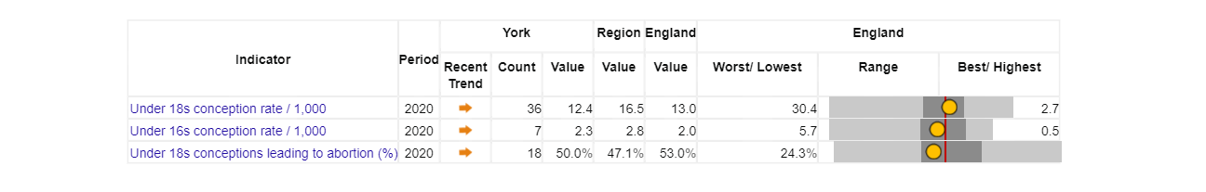
Figure 15: Chart showing under-18s conception indicators in York compared with England

In 2019, the under-18s conception rate per 1,000 females aged 15 to 17 years in York was 16.4, similar to the rate of 15.7 per 1,000 in England. The increase from 2018 was 2%. The rank within England for the under-18s conception rate was 76th highest (out of 149 UTLAs/UAs). Between 1998 and 2019, the decrease in the under-18s conception rate in York was 52%, compared to a 66% decrease in England.
Teenage conceptions leading to abortion have consistently followed national trends of approximately 50%.
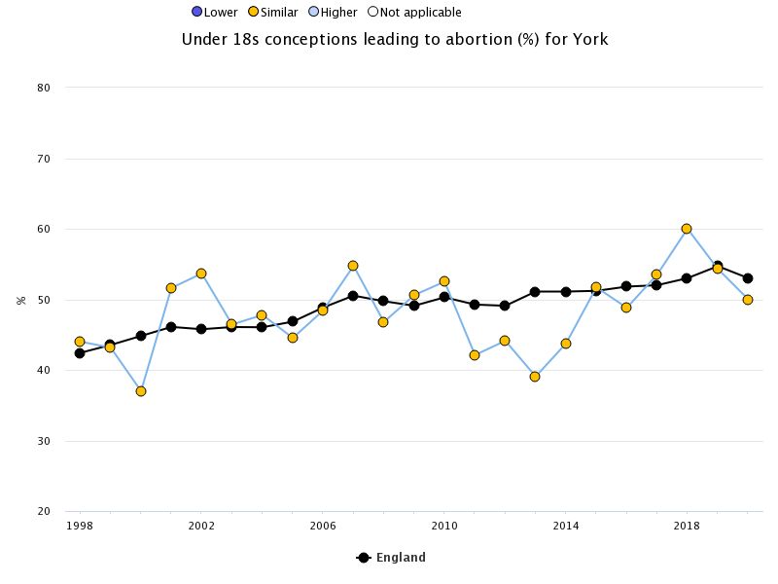
Figure 16: Under 18s rate of conceptions leading to abortion (%)

Figure 17: Teenage pregnancies by ward in York
Figure 17 shows the percentage rate of teenage pregnancies by ward in York. The highest rates are observed in Acomb and Hull Road wards which are ranked 8th and 9th out of 21 respectively in the 2019 Indices of Multiple Deprivation (IMD) domains. The wards of Fishergate, Westfield, Holgate, and Huntinton & New Earswick are also among the most deprived in York. The least deprived wards of Copmanthope, Wheldrake and Fulford & Heslington all report no instances of teenage pregnancy. Other wards with no cases of teenage pregnancy are also within the ten least deprived York wards.

6. Integrated Sexual Health Service Use

The following information is taken from the Genitourinary Medicine Clinic Activity Dataset (GUMCAD) report between December 2018 and June 2022. This section does not include data from primary care. YorSexual Health provides a service at Monkgate Health Centre. In 2018-2022 there were 26,713 attendances at the YorSexual Health Clinics in York. 22,933 of these were new consultations with 3,780 follow-up appointments. There were 17,570 patients in total. Of these, 12,459 (69.6%)were York residents however there was a sizeable proportion of service-users from nearby North Yorkshire (n = 3080). Patients accessing online services were counted as “Residents;” 16,571 of total consultations were online via Preventx.
In line with the overall population of York, the majority of people who used the sexual health service describe themselves as ‘White British’ (85%) or another white background (5%). 11% of the people who used the service reported they were LGBT with a higher proportion of this cohort being gay men.
The service was used approximately equally by men and women with men accounting for slightly more cases (52%).
• Of all the females who attended in the year, 69% were under 25, 25% were under 19, and 1% were under 16.
• Of all the males who attended in the year, 70% were under 25, 11% were under 19, and 0.2% were under 16.
In the autumn of 2022, the views of service users and professionals were sought, and people were invited to complete a short survey. Surveys were available online and in the sexual health clinics between October and November 2022. For the benefit of this needs assessment feedback from service-users will only be covered. Stakeholders and potential providers’ feedback is covered in the engagement report. The surveys were aimed respectively at prospective providers, stakeholders and service users. Circulation of the surveys was utilised by a variety of means:
- Service user
  - a poster developed and used in the specialist sexual health service and some community pharmacists signposting people to the survey.
  - A text message was sent via GP practices to all women who had attended for sexual health issues in the last 6 months
  - Information was placed on the YorSexualHealth Website
  - Information sent to schools to encourage the link to be shared.
  - A QR code was also included on the poster for ease of access.

Service Users
• 125 responses
- The majority of respondents were in the 16-24 age category (47%). No service-users at 56-59 years were represented however two were 60+ years
• More women (54.9%) than men completed the survey
- 15.7% of respondents identified as non-binary or gender variant

- 82.4% of respondents stated their gender identity was the same as the sex assigned to them at birth
• The majority describe themselves as White British (75%)
• The majority stated they were bisexual, gay or lesbian (47%).
- A bigger proportion of respondents preferred specialist sexual health services to GPs for support
• 59% (50 out 125) reported they were very satisfied or satisfied with their experience of specialise sexual health services
- 42.4% of users said they were extremely likely to recommend specialist services to family or friends
• The majority of people said they received everything they needed from their visit.
- The majority of service users (55%) attended for contraceptive advice. 50% of those citing this wanted advice on all types of contraception

- STI testing was still more common in clinic (46%) however 35% of testing was done online via Preventx

- Cervical screening was a service that many respondents stated they would like to access from the sexual health service
• The staff were described as friendly, professional, and non-judgemental and knowledgeable.

Negative comments included:
Some people felt that the waiting times were excessively long, and that the information available on the website was difficult to find.
Poor past experiences were also a common barrier to accessing services
People also felt embarrassed to ask for help in the first place
Equality of experience:
No statistical differences or clear trends were found when comparing service users’ responses according to their age, sexuality, or gender

7. Recommendations
1. To commission an integrated sexual health service which is flexible and responsive to population need and operates using evidence-based practice.
2. To work with a broad range of organisations, including social care teams, universities, and primary care, to ensure that the service is accessible and acceptable to service users.
3. To have an innovative service which is focused on improving outcomes and protecting the population of York.
4. To have a universal service which undertakes targeted activity to work towards equitable outcomes across the city
5. To have a focus on prevention by providing education resources
6. To address inequalities by providing targeted approaches to prevention work in areas of unmet need
7. To provide succinct information on the different types and locations of services provided to improve staff and user-experience

SPLASH Report
Commissioning local HIV sexual and reproductive health services, updated 2018: https://www.gov.uk/guidance/commissioning-regional-and-local-sexual-health-services
NICE (2014) guidance on contraceptive services for under 25s (PH51) https://www.nice.org.uk/guidance/ph51
https://www.ons.gov.uk/visualisations/censuspopulationchange/E06000014/
https://data.yorkopendata.org/dataset?sort=metadata_modified+desc&tags=ward+profiles
Sexual Orientation, UK: 2020
https://www.ons.gov.uk/peoplepopulationandcommunity/culturalidentity/sexuality/bulletins/sexualorientationenglandandwales/census2021
https://www.ons.gov.uk/peoplepopulationandcommunity/culturalidentity/genderidentity/bulletins/genderidentityenglandandwales/census2021
Ethnicity Data: Census 2021
York Open Data
Variation in Outcomes in Sexual and Reproductive Health in England
General Fertility Rate: https://fingertips.phe.org.uk/search/fertility
York Pharmaceutical Needs Assessment, 2022-2025, Chapter 4.8.5 Sexual Health
GUMCAD Report: All STI Diagnosis and Services 01/01/2018 to 30/06/2022 (restricted access)
World Health Organization- Sexually Transmitted Infections
Splash Report, 2022
Addressing the increase in syphilis in England: PHE Action Plan
https://www.who.int/news/item/28-11-2022-who-recommends-new-name-for-monkeypox-disease
Mpox Epidemiological Overview- 11 October
WHO: Cervical Cancer
Encouraging Uptake of the HPV Vaccine: A Guide for Nurses
WHO Guidelines on Teenage Pregnancy https://www.who.int/news-room/fact-sheets/detail/adolescent-pregnancy#:~:text=Adolescent%20mothers%20(aged%2010%E2%80%9319,birth%20and%20severe%20neonatal%20condition.
SPLASH Report
A Framework for Sexual Health Improvement in England
Indices of Multiple Deprivation in York

